**MessageUs**

The idea of the MessageUs system is the allow for bulk emails to multiple clients at the same time – it is a quick and easy way to communicate to many persons at the one time.

**Direct Messaging**

**NOTE I HAVE BROKEN THIS INTO ‘SCREENS’ BUT THE DEVELOP MIGHT DECIDE TO HAVE OVERLAYS, HE MIGHT DECIDE TO HAVE THE ‘SEND TO’ SELECTION FIRST, OR THE ADD ATTACHMENTS AT THE BOTTOM OF THE SCREEN – *THESE ARE SAMPLE SCREENS* – LET YOUR DEVELOPER USE HIS INITIAVE A LITTLE.**

**FIRST SCREEN**

This allows the operator to send a message to a select number of clients, a group of clients or a single client.

There is an option to add files to the system and each file will generate a text box that will allow the operator enter a comment related to that file. The file will be added to the email when sent…

You can add files to the message that is to be sent, you can add as many files as you want, there is no limit to the files that can be added. Beside each file there is the option to delete the file or to add a comment to the file…. The box for adding a comment to the file is a rich text box not a standard text box

If you have added a comment to a file, 3 dots appear beside the file as an indication that there is a comment recorded on the file.

The mess has a subject. The message CAN NOT BE SENT WITHOUT A SUBJECT

The message body is also a rich text box that – the message must have a body the body cannot be empty.

When you click on “Choose who Send this message to” you are moved onto a next screen.

**SECOND SCREEN**

The second screen is the selection screen for who the message is to be sent to. If you click on the “Choose who to Send this Message To” button (on the first screen) you

* MUST HAVE A SUBJECT
* MUST HAVE A MESSAGE BODY

On the Send to screen (second screen) you can choose to select

* All clients
* Active Clients
* Inactive Clients
* Group

Regardless of what list you select, inactive clients are always listed in ***RED***

If you select all clients, then all clients form the client list is loaded in and selected to send (I note that the demo screen does not have a check box beside each client),

If you select Active clients – then only active clients are loaded, if you select inactive clients then only inactive clients are loaded.

If you select a group then a dropdown box is displayed with a list of all GROUPS that have been created (see later in the groups section)

Regardless of the ‘group’ of contacts that the message is to be sent to the following is displayed

* Client Code
* Company Name (or surname & first name (i.e. “Ciaran Guilfoyle”) if there is no company name
* Primary and secondary email address

There is also a check box beside each entry and you can select or de-select a certain person to send the email.

Further beside each of the primary and secondary email addresses there is the option to select or de-select this particular email address ----- so you can choose to select or deselect the primary or secondary email address for each person that will be getting the message.

You must be able to select all or de-select all the entries in the send to list, and, you must be able to sort the entry columns in the send to list.

You cannot click on the “Send Message button” until you have selected at least one email to send the message to.

You need to be able to navigate back to the main message screen

There is a “Deselect all Inactive Clients” also – if this is selected then all clients who are Inactive are de-selected.

**SENDING THE MESSAGE**

When you click on “Send this Message” the user is given a summary screen

The Subject/ body and files to send are listed

“Some” of the “To” of the email are listed (say 10 for example) … If there are more then 3 dots are listed after the last entry in the list, if you click on the 3 dots you are presented with a full list of who is in the “To” list.

If you click on the “Back to Message Screen” you are brought back to the main/first message Screen

If you click on the Send message now the message is sent (See send message now section) and finally if you click on the Send Message Later, the message details are saved and unsent. (see saved messages section later)

**Sending Message now**

When you click on “Send this message now” button you are presented with an overlay – this overlay

has a list the option to select who the message is from – on this screen you can also click on cancel – if you click on cancel the overlay is closed.

As part of the SENDING MESSAGE NOW is a fundamental change in how all messages are recorded…

For now the message is sent to ‘who ever it is selected’ and to [Task@gbsco.ie](mailto:Task@gbsco.ie) BUT

A CHANNGE

There is a tab added to the client management screen – “Messages Sent”

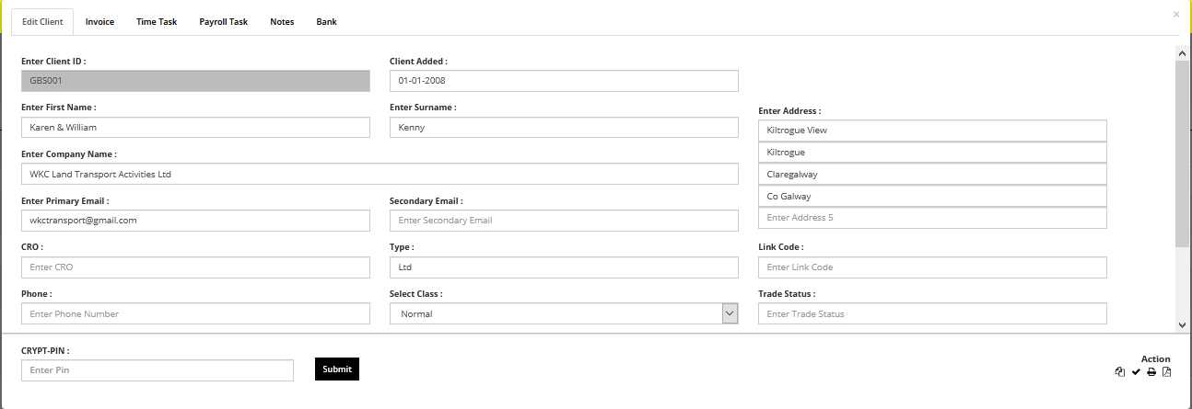

On this tab the detail of the message will be retained.

So when the message is sent to the client all the details are retained

* Subject
* Message from
* Date sent
* SOURCE ***
* Subject
* Body
* Attachments

It must be possible to TOTALLY recreate the message in a ‘view’ capacity. When you click the view the message you are presented with a screen very similar to the last screen on the DIRECT MESSAGING sample screen

Note – SOURCE the source will be the system module (VAT System/Client Request System… from which the message was created ***LATER*** other modules will be added to the message screen this will include

* PMS System (weekly and monthly)
* PAYE MRS system
* VAT system
* RCT system
* Client request system

So at some point all modules will interact with this core messaging system… But these additions are NOT part of ***this system***. Eventually every message saved in the system from MESSAGE US need to hold

attached files

date sent

from

subject

body

module

***SAVED MESSAGES***

If you opt to Send a message later -this message is saved and is available on the SAVED MESSAGE SCREEN – the saved message screen has all messages that are UNSENT.

The screen shows the

* Date Saved
* From (if available)
* Subject
* Number of attachments.
* Delete saved message button
* And an ACTIVATE BUTTON

If you click on the activate button then you are presented with the first DIRECT MESSAGE screen and the message acts like other messages as per above however on the FINAL Direct Message screen if you

* Send Message Now  
  Then the message is REMOVED from the saved message list
* Send Message Later   
  Any changes are saved to the message and the message is updated in the saved list…

Its is important that a process exists that a saved message can be brought to a close.

Therefore there will need to be ‘delete saved message option’

IT IS IMPORTANT THAT YOUR DEVELOPER LOOKS AT THE BIGGER PICTURE HERE – MESSAGES ARE GOING TO BE BECOME A FAR MORE IMPROTANT PART OF THE SYSTEM SOON SO SETTING UP MESSAGES SO THAT THEY WORK WELL GOING FORWARD WILL BE VWERY VERY IMPORTANT, IF YOU GET THIS RIGHT SAM THIS WILL BECOME SOMETHING THAT WILL GROW AND GROW AND GROW…. THIS IS ONE OF THEM IMPRTANT THINGS THAT WHE IT WORKS FOR US IT WORKS FOR YOU.

***I have not done a sample screen for saved messages…

***GROUPS***

An important part of the system is creating groups.

Each group that is in existence is listed in the “Groups On file” List…. This list outlines on all groups that have been created.

Each group lists the group name, number of members and a delete button.

When you click on “Create a new group”– you are asked to give the group a name. Once you give the group a name the group is listed in the “”Groups on file” list

You can select groups from the groups and add or remove members from this group. (it is difficult to show this on the sample screen but this is pretty standard functionality)

A client can only be a member of the group once. All inactive clients are listed in red on there is a “Remove inactive clients from group” button, this removes the inactive clients from the listed group. There is a hide inactive button that hides the inactive clients from the client list not from the “Group Member” list

PMS Group

There is a default PMS Group, you can not DELETE the PMS Group as an update button, this update button loads all ACTIVE clients who have payroll listed in the current week or month of the PMS system. In the Group Members section if the payroll in the current week AND month is “Do Not Complete” then this task is listed in blue in the Group Members list, but if either the current week or current month is “Complete”, then it is not listed in blue… There is a “Remove Inactive Payroll Clients from Group” button that removes all inactive clients from the PMS Group.

** I suppose that the PMS Group is a ‘system’ group, there may be more system groups such as a VAT system group…